**Domain Model**

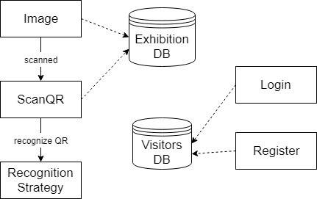

**Architectural Design**

I choose to implement the 3 Layers Architecture, composed of Presentation Layer, Business Logic Layer, and Data Layer, arranged as in the following schema:

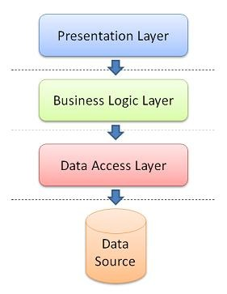

In the Data Access Layer, I will make the connection to the Exhibition and Visitors databases. In the Business Logic Layer I will process the information. The Presentation Layer will be the Android interface.

**Deployment Diagram**

